SWOT and PEST analysis
[This analysis took place during the discussion of the focus-group formed by those members who had been with SWAN since its founding in 2006. Their participation was prompted by their longest experience with SWAN, its operational process and problems SWAN faced during the 4 years of existence. The participants: Siberian Initiative (Russia), Humanitarian Action (Russia), HOPS (Macedonia), Bliss without Risk (Czech Republic), Tais Plus (Kyrgyzstan), UHRA (Ukraine), DIA+LOGS (Latvia) and Aliya Rakhmetova]

By Grigor Simonyan

Situational evaluation
In order to critically analyse the situation where SWAN operates, this paper considers the findings of the Focus Group Discussion (FGD) conducted in Ohrid, Macedonia during annual meeting of SWAN members. FGD has been complimented by informal observations and interviews conducted with the representatives of regional organisations and SWAN community based research project report (2009).
The aim of situational analysis is to develop key issues that need to be addressed in overall PR campaign proposal.

SWOT analysis
Through SWOT analysis, the strong and week points have been listed by respondents. It aids to develop a picture of current environment of SWAN. In addition, opportunities and threats SWAN may face in the future have been identified. A complete list of SWOT analysis is available in below.
It should be also noted that participation of Aliya was mostly limited to translation, even though she has bigger picture of network development.
The respondents present at the discussion were all involved; however, most active members were the representatives from Russia and Kyrgyzstan.

Strong points
Most explicitly all respondents acknowledged that regional member organisations of SWAN are motivated and enthusiastic. Many of the organisations have been listed and praised for their dedication. The motivation to work within SWAN was explained with the existence of common interests and problems.
The member organisations have also been described as professional and experienced in what they do as they are armed with professional team and organisational capacity. Many have been identified to have work experience in the field of HIV/AIDS, harm reduction, advocacy etc.
The respondents did recognise the support of SWAN as an umbrella organisation that connects regional organisations with each other and offers exchange of experience between organisations.

Weak points
Evidently there has been a bigger list of weak points proposed by the respondents, as well as a bigger list of threats has been brought up compared to opportunities.
Poor knowledge of languages has been singled out by all respondents, which could also be explained with the constraints faced during the general meeting and the focus group discussion itself. Member organisations speak different languages and have no common language for communication.
The respondents explicitly felt insecure and unsustainable in terms of their funding. They expressed grief concern that all the work will disappear in case OSI stops funding as currently they have no alternative sources.
Even though organisational capacity has been noted as a strong point, others respondents (particularly Kyrgyzstan) put down organisational capacity as a weak point as well. All respondents agreed that advocacy is empowered when SWs are directly involved and disclosed, nevertheless, SWs do not feel comfortable to disclose in their native countries.
SWAN member organisations come from diverse legislative, religious and cultural backgrounds, which constraints to elaborate a common strategy. For instance some member countries are developing campaigns to decriminalise sex work, whereas, others are focusing on legalisation and antiviolence.
Most interestingly, respondents see migration as a weak point for SWAN development as many team members as well as beneficiaries migrate and the organisations lose both trained team and motivated activists.
Inter network and inter organisational disagreements have been revealed as a result of discussions. It has been found out that there is poor tolerance within the groups the organisations work with (classification of SWs, based on ethnic background, status (street worker, escorts). It has been also highlighted, that societies and police are less tolerant when dealing with SWs of other ethnicity.
The respondents showed resistance to cooperate with other activist groups (LGBT, HIV/AIDS, harm reduction etc), explaining it as ‘losing identity’ and undergoing bigger projects of other organisations.

Opportunities
Even though there has been reluctance to network with other interest groups, it has been considered as an opportunity for SWAN to make the network visible.
The respondents also proposed participating in international conferences both for SWAN and regional organisations.
Considering the fact that SW activists did not feel safe to disclose in their native countries, the respondents suggested exchanging SWs who could speak on behalf of the group in other countries.

Threats
The respondents noted that in parallel to their activist work, there are others, who are fighting sex work on institutional level.
As noted in the weak points, the respondents mentioned migration and high turnover of activists. Difference of interests, such as legalisation or decriminalisation brought disagreements within organisation, which could be also followed during the discussion between respondents.
Kyrgyzstan referred to the role of religious institutions as a prior threat to SWAN and its member organisations. So the other respondents confirmed that religion could be a threat not only in Muslim countries, but also in Christian ones.
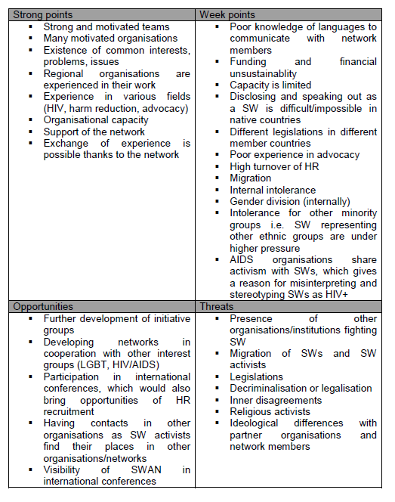
PEST analysis
PEST analysis aims to provide environmental description in terms of political, economical, social and technological situations. A full table of the analysis is available below.

Political screening
In this part of the interviews, respondents gave a more vivid picture of political, economical, social and technological situation where they operate. It also revealed the existence of bigger split between member organisations in terms of legal priorities, levels of democracy, and the level of corruptions.
Political unions, such as EU, OSCE have been discussed, as the latter develop an opportunity for lobbying for SWAN and regional organisation. As it has been noted in the previous analysis, migration is a significant issue for organisations, but due to visa regime SWs are facing problems to move, which results in illegal migration and further legal complications. Respondents also highlighted the fact that due to illegal migration of SWs a belief is being formed according to which SWs are victims. Particularly organisations dealing with trafficking tabloid the opinion and contribute to existing stereotypes about SW.
Juridical system has been a subject of discussion, when analysing political situation. Majority of respondents stressed, that court is prejudiced when it comes to work with SWs. Interestingly, most of the respondents identified female judges as more antagonistic towards SWs than their male counterparts.

Some of respondents noted that very often SWs are used for political PR of a political party or an individual politician.

Economic analysis
Participants of FGD had disagreements when discussing economic situation in their countries, which lead to the conclusion that due to different living standards the organisations have different priorities.
Lacks of financial resources also cause poor opportunities for the network organisations to participate in international events i.e. conferences, training, which therefore, leads to little opportunities to make SWAN visible.
It is worth mentioning, that organisations considered fundraising regionally where MoH could be a possible player.

Social screening
Religion obviously plays an important role for organisations dealing with SWs.
Particularly in Muslim countries (Kyrgyzstan was the only Muslim country present at FGD). Consequently, the issue of moralisation of SW emerge in countries where religion/church has a strong position.
Migration has been a subject for discussion both in previous analysis as well as in the political analysis. However, the discussions on migration in this part has been more complex and covered some issues concerning illiteracy (or poor awareness of rights) of SWs which bring a vibrant net of further problems.
Respondents referred to stereotypes around SW, and noted that many of them are typical of a particular ethnicity or other group (Natasha, blond etc.).

Technological analysis
Many of the respondents claimed they are not technologically advanced, however, it was explained with poor skills of managing e-marketing and expenses required, rather than unavailability of internet or technologies in their countries.
It could be observed that in the respondents from East Europe were more technologically equipped and it was the representative of Kyrgyzstan who saw technological development more problematic.
Present teams of network members need training to develop their computer skills to be technologically more advanced.

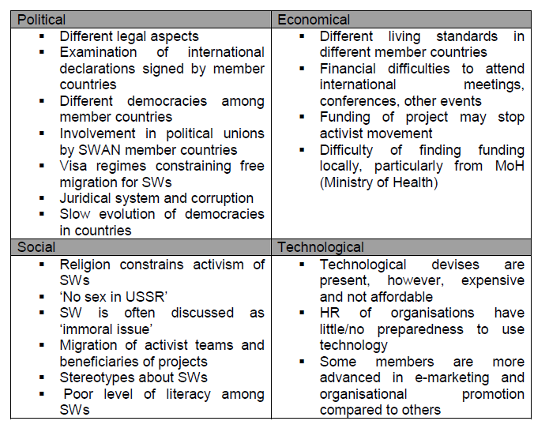

Analysis of current and potential publics
Identification of the main stakeholders to be considered by SWAN has been done considering two criteria: power to influence (both negatively and positively) SWAN activities, and interest in the network.
Secondly, activities should be initiated to empower a particular group/take away the power/raise interest or decrease it.

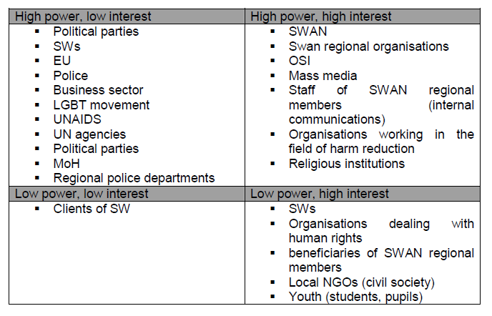

Key issues
As a conclusion to the analysis provided above the following key points for PR campaign are acknowledged:
- Police violations have the highest rate in all countries where SWAN members are present; however, there is high risk of deepening it, if organisations voice the problem.
- The concept of SW should be introduced as work, rather than other stereotypical approaches (victimising, moralising).
- Diversity of SW should be highlighted as it is often generalised in public perception.
- Migration of SWs (also illegal) migration should be considered from the perspectives of loosing trained HR, however, it can be also be an alternative communication channel.
- Many of the countries (both CIS and former Yugoslavian countries) have increased the role of religion and rightist media, as the latter have been banned in communist countries.
- Borderline with other activist organisations (LGBT, HIV, harm reduction) should be kept, but partnership with these organisations should not be rejected.
- Transgender SWs, male SWs and SWs coming form ethnic minority groups are under stronger pressure. Hence, minority groups among SWs can be viewed as separate target groups.
- Negative media coverage is a major constraint for SWAN member organisations to make themselves visible positively

