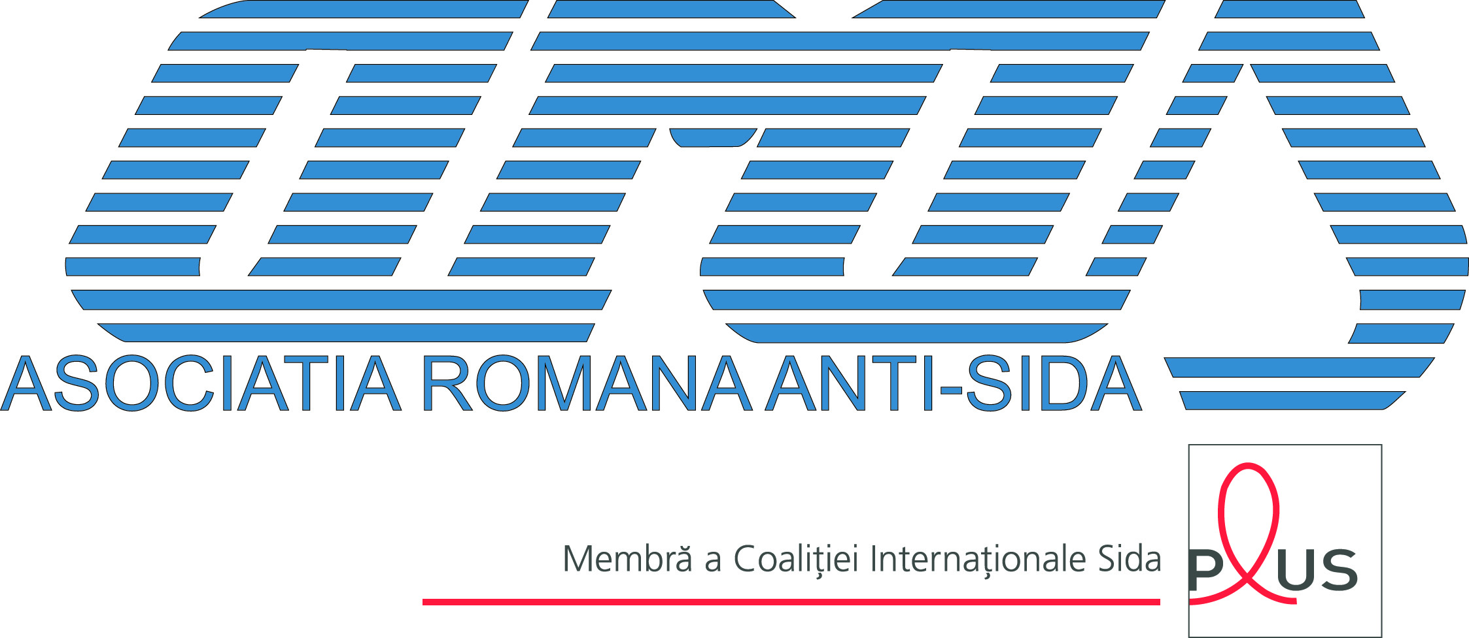
ARAS - Asociaţia Română Anti-SIDA
Piaţa Presei Libere 1, corp B2, et. 3, cam. 323,
Sector 1, 013071, Bucureşti, România
Tel.: +4(021)319.07.71; Fax: +4(021)318.82.51
SIDA HelpLine: 0 800 800 033, e-mail: aras@arasnet.ro
www.arasnet.ro | www.hivnet.ro | www.a-doua-sansa.ro

16 December 2011

Open Letter
Same rights, same responsibilities

Each year, on Decemver 17th, NGOs from all over the world (mainly NGOs of CSWs) draw the attention on the need to stop violence and abuse against persons involved in commercial sex work. Serious infringements of the human rights, violence, stigma and limitation of the civil rights, in a context that incriminates prostitution, all these increase the vulnerability of the CSWs to HIV/AIDS.
In Romania, prostitution is a crime and can be punished with prison from 3 months to 3 years. According to the Law 61/1990, sollicitation is considered to be a contravention and can be punished with a fine.
Persons involved in commercial sex work are very often abused and aggressed by clients or pimps, but also by other persons. In these cases, instead of punishing the aggressors, the system prefers to arrest of fine the girls; moreover, denouncing an abuse equals/involves giving yourself up to the police.
Women involved in prostitution are fined several times a day for solliciting, therefore they get to owe the financial authorities impressive amounts of fined which are not paid.
Prostitution is a reason for labelling, blaming, disapproving by the society. Violence is a manifestation of stigma and discrimination.
Persons involved in commercial sex work are seend as the only ones who bear the responsibility. Clients, meaning the persons who ask for the services and pay for them, are not perceived as responsible from the social point of view. On the contrary, public messages sound like „the poor client (a man), got sick because of a minor prostitute”.
What ought we to do?
To discuss openly about prostitution, to involve manily the women and, in general, all the persons involved in commercial sex work, both in discussions and in the decision taking process that regards them.
To consider women and persons involved in prostitution as equal citizens – who have the the same rights as us, and not only the same responsibilities.
To give up stigma based on moral laws, good intentions and different perspectives, and strenghtened by laws that just punish without having any effect on the security and health of the citizen and of the community.
To punish the aggressions and the abuses towards persons involved in prostitution. To give up the practice based on the ideea that the victim is the guilty one.
To consider that clients/men are both part of the problem and of the solution, as they are the ones who ask for the services and pay for them.
This document has been drafted by ARAS – the Romanian Association Against AIDS, a non-governmental organisation that implements, among others, health education programs for persons involved in commercial sex work.
This document is supported by the following institutions:

http://www.who.int/gender/documents/sexworkers.pdf

